This is the code to be installed in the Arduino NANO.
Built with Arduino IDE version 1.8.13
#include <SoftwareSerial.h>
#include <Wire.h>
#include <LiquidCrystal_I2C.h>
#include <SPI.h>
#include <MFRC522.h>
All of these includes are available from the IDE Library Manager as downloads.

First install the Arduino IDE (defaults recommended)
Find Arduino in the Documents folder
Copy and paste the SerialRFID_Arduino folder into the Arduino folder.
NOTE: do not change the name of this folder
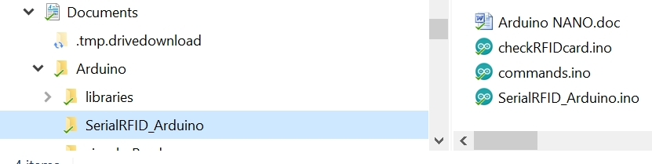

Each NANO requires a unique address before being connected on the RS-485 bus. The line to change is highlighted in yellow below.
- The address must be a capital letter
- Legal addresses are A through Y
- The address must be in single quotes ‘A’ and not double quotes “A”
